**A Minor Project Synopsis**

**on**

**Attendance Processing System**

Submitted to Manipal University Jaipur

towards the partial fulfillment for the award of the degree of

**Bachelor of Technology**

**In Computer Science Engineering**

By

**Naman Kakroo**

**209301395**

Section: **A**

Under the Guidance of

**Dr. Yadvendra Pratap Singh**

**Department of Computer Science Engineering**

**School of Computer Science**

**Manipal University Jaipur**

**2022-2023**

**Synopsis**

1. **Introduction**

The proposed project is an attendance processing system that utilizes AI and machine learning to mark attendance for a class through facial recognition. The system will be designed to operate on a mobile application interface, making it easily accessible and convenient for both students and teachers.

1. **Motivation**

The motivation behind this project is to streamline the attendance-taking process in classrooms, making it more efficient and less prone to errors. The traditional manual method of attendance-taking is time-consuming and often leads to discrepancies. By using facial recognition technology, the system will be able to accurately identify students, reducing the likelihood of errors and making the process much faster. The use of AI and machine learning will also help to automate the attendance-taking process, freeing up valuable time for teachers to focus on other aspects of classroom management.

1. **Project Objectives**

The primary objectives of this project are as follows:

• To design and develop an attendance processing system that uses AI and machine learning for facial recognition.

• To create a mobile application interface for the system to make it easily accessible for both students and teachers.

• To ensure that the system is accurate and reliable, with minimal errors in attendance-taking.

• To integrate the system with existing school management software, making it easy to incorporate into the school's existing technology infrastructure.

1. **Literature Review:**

**4.1 Requirement Analysis**

The facilities required for the proposed attendance processing system are:

Computing hardware: A high-performance computer system is required to host the AI and machine learning models, handle the processing requirements of the algorithms, and store the data.

Software development tools: Programming languages such as Python and Java, integrated development environments (IDEs) such as PyCharm and Eclipse, and version control systems (VCSs) such as Git are required to develop and maintain the system.

AI and machine learning frameworks: Frameworks such as OpenCV, TensorFlow, and Keras are required to develop and train the facial recognition and machine learning models.

Mobile application development tools: Mobile application development platforms such as Android Studio, Xcode, or React Native are required to develop and maintain the mobile application interface.

Cloud infrastructure: A cloud infrastructure, such as Amazon Web Services (AWS), Google Cloud Platform (GCP), or Microsoft Azure, is required to deploy and host the system, provide scalability, and availability to the system.

Database or data storage solution: A database or data storage solution, such as MySQL or MongoDB, is required to store the attendance data and student information.

Communication channels: The mobile application should be integrated with communication channels such as SMS, email, or push notifications to provide alerts to the students and teachers about attendance and any updates.

Testing environment: A testing environment, such as a virtual machine or a cloud-based solution, is required to test the system and ensure its functionality and performance.

* 1. **Technology Used**

The following tools will be used in the implementation of the designed system. They’ve been divided in to two categories; Mobile and Desktop tools.

• **Mobile Tools**

The face detection module will use OpenCV library for implementation by use of the frontal Haar Cascade face detector in either Android studio. OpenCV for Android Library - (Open-Source Computer Vision) is a library of programming functions mainly aimed at real-time computer vision. Android Studio/ Eclipse IDE - Android Studio is the official IDE for Android application development, based on IntelliJ IDEA.

• **Desktop Tools**

EmguCV Library - EmguCV is a cross platform .Net wrapper to the OpenCV image processing library. OpenCV/EmguCV uses a type of face detector called a Haar Cascade. The Haar Cascade is a classifier (detector) trained on thousands of human faces. Visual Studio - Visual Studio is able to build and run the solution examples after a proper configuration of EmguCV. The desktop software will implement the two sub-systems (Training set manager and Face recognizer) together with face detector in windows form.

1. **Comparison/Table**

|  |  |
| --- | --- |
| **Pros** | **Cons** |
| * **Reduces the workload of teachers in the attendance-taking process, giving them more time to focus on other tasks.** * **Provides a user-friendly and intuitive interface for students to use when checking their attendance records.** * **Minimize the need for physical contact between individuals during attendance-taking, promoting a safer and more hygienic environment in the classroom.** * **Automate and streamline the attendance tracking process & to reduce the time and effort required to manage attendance records** | * **Technical issues: Any technology can malfunction and software may not function properly, resulting in loss of data or inaccurate attendance records.** * **Privacy concerns: The use of attendance processing systems may raise privacy concerns as it may collect and store personal information of individuals.** * **Training: Employees and students need to be trained on how to use the system properly, and some may not be comfortable with new technology.** * **Data accuracy: While an attendance processing system can automate the tracking of attendance, it still relies on data input and may not be 100% accurate.** |

1. **Methodology**

The project will follow a structured methodology, consisting of the following phases:

**• Requirement gathering:** In this phase, the requirements for the system will be gathered by conducting interviews with stakeholders, analyzing the existing attendance-taking process, and identifying the key features that the system must have.

**• Desig**n: In this phase, the system's design and architecture will be created, including the user interface and workflow. The design will take into consideration the objectives and requirements gathered in the previous phase.

**• Development:** The system will be developed using AI and machine learning technologies for facial recognition. The mobile application interface will also be developed in this phase.

**• Testing:** The system will be tested for accuracy, reliability, and performance. This phase will include both functional and non-functional testing.

**• Integration:** The system will be integrated with the school's existing technology infrastructure, including school management software and any other relevant systems.

**• Deployment:** The system will be deployed and made available to teachers and students. User feedback will be collected and analyzed to identify any areas for improvement.

**6.1 Flowchart:**

Following flowchart explains the process of the flow of information throughout the process

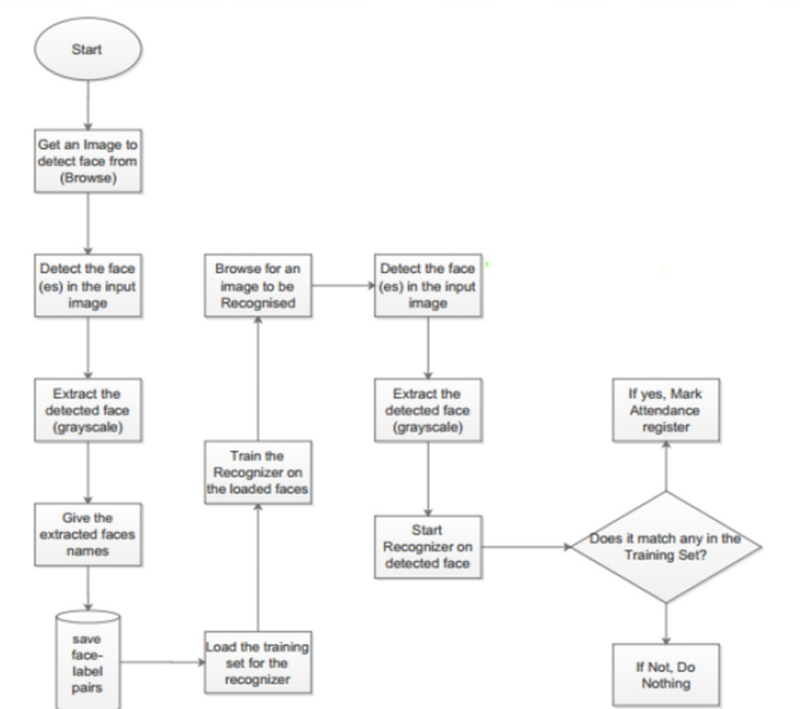

* 1. **Working (ref. Flowchart above)**

The system will comprise of two modules.

The first module, face detector is a mobile component, which is basically a camera that captures student faces and stores them in a file using computer vision face detection algorithms and face extraction techniques.

The system will be presented an image either via camera or from memory and it must detect the number of faces on it automatically. After identifying faces, the system should crop the faces from the image and store them in memory for image recognition which will be done in the second step. The system should be able to automatically count the number of faces detected on the image.

The second module is a application that does face recognition of the captured images (faces) in the file, marks the students register and then stores the results in a database for future analysis.

The second step will be the recognition part where the system will be able to match faces from the stored dataset and compare it to the input data from the first step.

A software will be used for this system which automatically sorts out the faces. The software will be inter-active so to facilitate interaction between multiple tasks as required. Because the system has two steps, the second phase of the system will involve the training of images on a dataset that are to be used for recognition

1. **Gantt chart**

A Gantt chart is a visual representation of the project timeline and can be used to track progress and monitor the status of each task. Here is an example of a Gantt chart for the attendance processing system project:

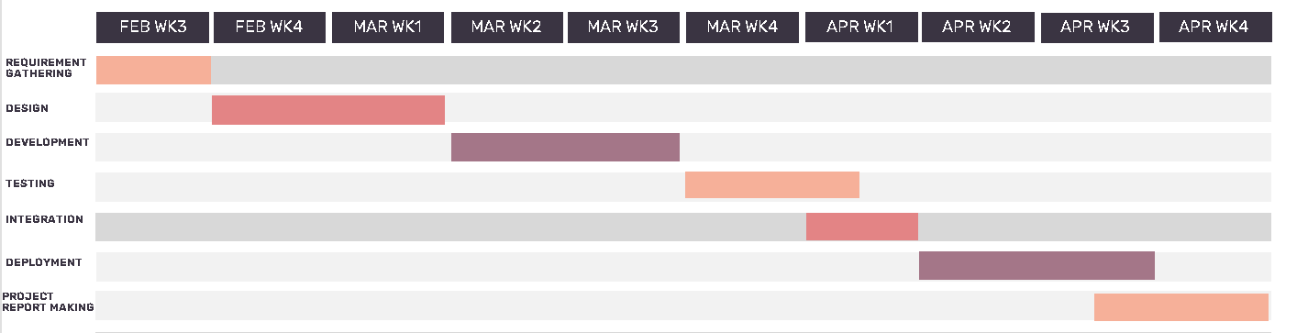

1. **Conclusion**

In conclusion, the attendance processing system that uses AI and machine learning to facially recognize and mark attendance of a class on a mobile application interface has the potential to revolutionize the traditional attendance-taking process in educational institutions. By leveraging the power of AI and machine learning, the system can provide accurate and efficient attendance records in real-time, making it easier for teachers to manage and track the attendance of their students. This attendance processing system offers a modern and streamlined approach to attendance-taking, benefiting both teachers and students alike. With its potential to increase efficiency and accuracy, the system could become an essential tool for educational institutions looking to enhance their attendance management process.

1. **Bibliography/References:**

L. Ma, Y. Li, J. Xu, et al. (2018). Mobile Face Recognition with Centralized Computing in the Cloud. IEEE Transactions on Mobile Computing.

Y. Zhang, H. Wang, X. Wan J. Liu, Y. Liu, et al. (2021). An Efficient Mobile-Based Attendance System Using Face Recognition and Location.

et al. (2019). Multi-Task Deep Learning for Real-Time Facial Analysis and Expression Recognition. IEEE Access.

J. Liu, Y. Liu, et al. (2021). An Efficient Mobile-Based Attendance System Using Face Recognition and Location. IEEE Access.

https://www.pmu.edu.sa/attachments/academics/pdf/udp/coe/dept/ee/face_detection_systm_report.pdf